VELAMMAL BODHI CAMPUS

**GRADE:** X **(FOUNDATION) PART TEST – 2 SUB:** MATHS

**DATE:** 18.12.2023 **MARKS:** 80 (3 HOURS)

**…………………………………………………………………………………...................**

**I**.**ANSWER THE FOLLOWING MCQS. 20*1=20M**

1.  Which of the following is not irrational?  
(a) (2 – √3)2 (b) (√2 + √3)2 (c) (√2 -√3)(√2 + √3) (d)27/√7

2. If two positive integers m and *n* are expressible in the form *m* = *pq*3 and *n* = *p*3*q*2, where *p*, *q* are prime numbers, then HCF (*m*, *n*) =  
(a) *pq* (b) *pq*2 (c) *p*3*q*2 (d) *p*2*q*2

3. If 𝛼,ꞵ be the zeroes of the quadratic polynomial 2 – 3x – x 2,then 𝛼 +ꞵ = _______

a) 2 b) 3 c) 1 d) -3

4. If 𝛼,ꞵ are the zeroes of polynomial f(x) = x 2 - p(x + 1) – c, then (𝛼+1)(ꞵ+1)=

a) c – 1 b) 1 – c c) c d) 1 + c

5. If one zero of the polynomial f(x) = (k 2 + 4) x 2 + 13x +4k is reciprocal of the other, then k =

a) 2 b) -2 c)1 d) – 1

6. If x = 1 is a common root of ax 2 + ax + 2 = 0 and x 2 + x + b = 0 then, ab=

a) 1 b) 2 c) 4 d) 3

7. If sin𝛼 and cos𝛼 are the roots of the equation ax 2 + bx + c = 0, then b 2 =

a)a2 – 2ac b) a 2 + 2ac c) a 2 – ac d) a 2 + ac

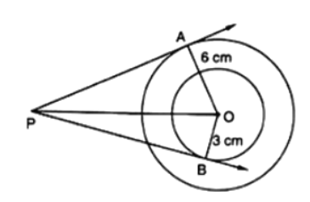8. The value(x) of k for which the equation (k + 1)x 2 – 2(k – 1)x + 1 = 0 has real and equation roots is:

a) k = 0, -3 b) k = 0, 3 c) k = 0, 4 d) None of these

9. In figure, if AP = 10cm, then BP =

a) 91cm b) 127cm c) 119cm d) 109cm

10.If TP and TQ are the two tangents to a circle with centre O so that ∠POQ = 110°, then ∠PTQ is equal to

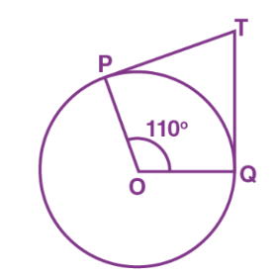(a) 60° (b) 70° (c) 80° (d) 90°

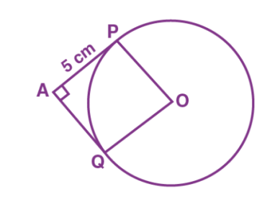11.In the figure below, the pair of tangents AP and AQ drawn from an external point A to a circle with centre O are perpendicular to each other and length of each tangent is 5 cm. Then the radius of the circle is

(a) 10 cm  (b) 7.5 cm (c) 5 cm  (d) 2.5 cm

12.In a circle of radius 21 cm, an arc subtends an angle of 60° at the centre. The length of the arc is;

(a) 20cm (b) 21cm (c) 22cm (d) 25cm

13. If the circumference of a circle and the perimeter of a square are equal, then

(a) area of the circle = area of the square

(b) area of the circle > area of the square  
(c) area of the circle < area of the square  
(d) nothing definite can be said about the relation between the areas of the circle and square.

14. The total number of events of throwing 10 coins simultaneously is  
(a) 1024 (b) 512 (c) 100 (d) 10

15. Which of the following can be the probability of an event?  
(a) – 0.4 (b) 1.004 (c) 18/23 (d) 10/7

16. A girl calculates that the probability of her winning the first prize in a lottery is 8100. If 6,000 tickets are sold, how many tickets has she bought?  
(a) 400 (b) 750 (c) 480 (d) 240

17.Which of the following is not a measure of central tendency?

A) Mean B) Median C) Mode D) Standard deviation

18.The mode and mean is given by 7 and 8, respectively. Then the median is:

(a) 1/13 (b) 13/3 (c) 23/3 (d) 33

19.If the mean of first n natural numbers is 3n/5, then the value of n is:

(a) 3 (b) 4 (c) 5 (d) 6

20.Consider the following frequency distribution of the heights of 60 students of a class:

|  |  |  |  |  |  |  |
| --- | --- | --- | --- | --- | --- | --- |
| Height (in cm) | 150-155 | 155 – 160 | 160 – 165 | 165 – 170 | 170 – 175 | 175 – 180 |
| Number of students | 15 | 13 | 10 | 8 | 9 | 5 |

The sum of the lower limit of the modal class and upper limit of the median class is

(a) 310  (b) 315  (c) 320  (c) 330

**II**.**ANSWER THE FOLLOWING VERY SHORT ANSWER TYPE QUESTIONS. 5*2=10**

21.Find the greatest number that will divide 445, 572 and 699 leaving remainder 4,5,6 effectively

22. Find the zeros of the following quadratic polynomials -6x2+3-7x and verify the relationship between the zeros and the coefficients.

23.Find the discriminant of the quadratic equation 3x2+10x+ =0 and hence find the nature of the roots.

24. Prove that a line drawn through the end point of a radius and perpendicular to it is a tangent to the circle.

25. A bag contains 12 balls of which 'x' are white.  
(i) If one ball is drawn at random, what is the probability that it will be a white ball?  
(ii) If 6 more white balls are put in the bag, the probability of drawing a white ball will be double than that in case (i), Find x.

**III. ANSWER THE FOLLOWING SHORT ANSWER TYPE QUESTIONS. 6*3=18**

26. Prove that 2+5 $\sqrt{3}$ is an irrational number, given that $\sqrt{3}$  is an irrational number.

27.If 𝛼,ꞵ are the zeroes of the quadratic polynomial f(x)= x2-px+q, prove that

28. Rohan's mother is 26 years older than him. The product of their ages (in years) 3 years from now will be 360. Find Rohan's present age and his mother’s present age.

29. Prove that a parallelogram circumscribing a circle is a rhombus.

30. A car has two wipers which do not overlap. Each wiper has a blade of length 25 cm sweeping through an angle of 1150. Find the total area cleaned at each sweep of the blades.

31.Apply step-deviation method to find the AM of the following frequency distribution.

|  |  |  |  |  |  |  |  |  |  |  |
| --- | --- | --- | --- | --- | --- | --- | --- | --- | --- | --- |
| Variable(x): | 5 | 10 | 15 | 20 | 25 | 30 | 35 | 40 | 45 | 50 |
| Frequency(f): | 20 | 43 | 75 | 67 | 72 | 45 | 39 | 9 | 8 | 6 |

**IV. ANSWER THE FOLLOWING LONG ANSWER TYPE QUESTIONS. 4*5=20**

32. Is the following situation possible? If so, determine their present ages. The sum of the ages of two friends is 20 years. Four years ago, the product of their ages is years was 48.

33(a). A triangle PQR is drawn to circumsribe a circle of radius 8 cm such that the segements QT and TR, into which QR is divided by the point of contact T, are of lengths 14 cm and 16 cm respectively. If area of ΔPQR is 336cm2, find the sides PQ and PR.

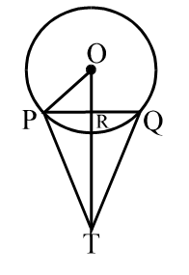 OR

33(b). In the given figure, PQ is a chord of length 8 cm of a circle of radius 5 cm. The tangents at P and Q intersect at a point T. Find the length TP.

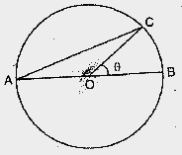34(a).In a fig AB is the diameter of a circle, centre O. C is a point on the circumference such that ∠COB=θ. The area of the minor segment cut off by AC is equal to twice the area of the sector BOC. Prove that

Sin(θ/2) cos(θ/2)=π(1/2−θ/120).

OR

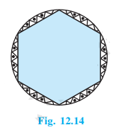34(b). A round table cover has six equal designs, as shown in Fig. 12.14. If the radius of the cover is 28 cm, find the cost of making the designs at the rate of ₹ 0.35 per cm2. (Use √3 = 1.7)

35.The median of the following data is 50.Find the values of P and Q,if the sum of all the frequencies is 90.

|  |  |  |  |  |  |  |  |
| --- | --- | --- | --- | --- | --- | --- | --- |
| Marks: | 20-30 | 30-40 | 40-50 | 50-60 | 60-70 | 70-80 | 80-90 |
| Frequency: | P | 15 | 25 | 20 | Q | 8 | 10 |

**V. ANSWER THE FOLLOWING CASE BASED QUESTIONS. 3*4=12**

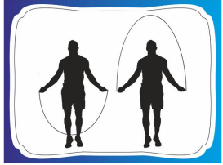36. During the skipping through skipping rope, its look like the in the form of parabola. It is a natural examples of parabolic shape which is represented by a quadratic polynomial. Similarly, we can observe in many other cases forming a in a variety of forms of different parabolas.

(i) Write the standard form of a polynomial of degree 2. (1M)

ii) If α, −α are the zeroes of the quadratic polynomial 2x2 −3(k −4) x −8, then find the value of k . (2M)

OR

What are the zeroes of the polynomial P(x) = x2 −1? ( 2M)

(iii) If the sum of the zeroes is p and product of the zeroes is −p , then find the quadratic polynomial. (1M)

37. A brooch is a small piece of jewellery which has a pin at the back so it can be fastened on a dress, blouse or coat. Designs of some broochs are shown below. Observe them carefully

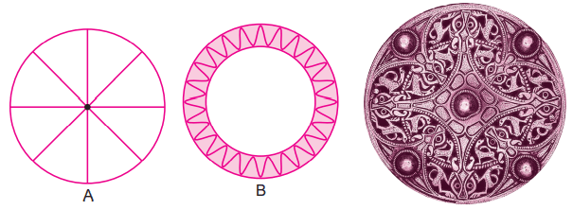

***Design A:*** Brooch A is made with silver wire in the form of a circle with diameter 28 mm. A wire used for making 4 diameters which divide the circle into 8 equal parts.

***Design B:*** Brooch B is made of two colours gold and silver. Outer part is made with gold. The circumference of silver part is 44 mm and the gold part is 3 mm wide everywhere.

Based on the above information, answer the following questions:

*Refer to design A*  
(i) The total length of silver wire required is  
(a) 180 mm (b) 200 mm (c) 250 mm (d) 280 mm

(ii) The area of each sector of the brooch is  
(a) 44 mm2 (b) 52 mm2 (c) 77 mm2 (d) 68 mm2

*Refer to design B*  
(iii) The circumference of outer part (golden) is  
(a) 48.49 mm (b) 82.2 mm (c) 72.50 mm (d) 62.86 mm

(iv) A boy is playing with brooch B. He makes revolution with it along its edge. How many complete revolutions must it take to cover 80π mm ?(a) 2 (b) 3 (c) 4 (d) 5

38. A survey was taken at a high school, and the results were put in a circle graph. The students were asked to list their favourite colours. The measurement of each central angle is shown. If a person is chosen at random from the school, find the probability of each response.

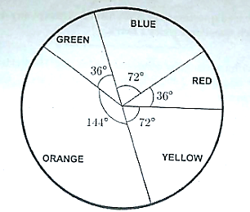

(i) What is the probability of favourite colour being red? (1)

(ii) What is the probability of favourite colour being blue or green? (1)

(iii) What is the probability of favourite colour not being red or blue? (2)

OR

What is the probability of favourite colour not being orange or green? (2)